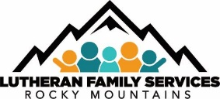
Lutheran Family_ Services Rocky Mountains
Foster Care

Training Documentation and Approval Form
(Please use ONLY when certificate is not provided)

Name:
Date: _

Title of Training:
Please check category of training (check all that apply):
general cultural responsiveness trauma informed

Name of presenter or author:
□Book □Audio □Video □Workshop Internet Other (list) _
Please list number of pages, minutes, or hours of training: _
(#of hours granted will be hour-for-hour, actual workshop length, or 1 hour per 30 pages.)

Report Outline
(Use back or additional sheets as needed)

What was the training material about?

What new information did you gain?

How will you use it in fostering children?

Number of training credit hours granted: Date: _ Approved by LFSRM staff member:
In Accordance with Rule #7.708.65.C&D
Rev. 12/2023

